Yuntianhua® POM Instruction Manual
1 Brief Introduction of Yuntianhua® POM
POM is an engineering plastic with good comprehensive performance. According to the different polymerization method, POM is divided into acetal copolymer and homopolymer. Currently, majority of the POM products in the whole world is acetal copolymer. Compare with homopolymer, acetal copolymer has superior thermal stability and processing ability. In1999, through importing advanced technology from Europe, Yunnan Yuntianhua Co., Ltd. became the first Chinese domestic producer of high-quality acetal copolymer resin. At present, total POM production of Yuntianhua is 90,000 MTPY, having one production bases in Shuifu County, Yunnan Province and another in Changshou District, Chongqing City.

At the same time of continuously expanding its production scale, Yuntianhua has been also cooperating with some famous universities in China, such as Sichuan University, Qinghua University, etc., to jointly establish R&D center and technical service center. To upgrade its R&D ability and increase the core competence of Yuntianhua® POM, Yuntianhua invested huge capital in 2009 constructing an engineering plastic R&D center in Changshou District, Chongqing City. Construction of this R&D will be completed and put into operation in June 2010. The R&D center will be helpful to improve Yuntianhua’s ability in new product research and product application development. Through continuous improving of Yuntianhua® POM quality and increasing number of grades, Yuntianhua is ready to provide excellent quality of POM products and satisfactory services to all the customers.

Yuntianhua® POM produced by Yunnan Yuntianhua Co., Ltd. has excellent comprehensive performances. Main features are:
(1) High rigidity and mechanical strength;
(2) Stable impact strength in a wide temperature range and excellent flexural strength even at high temperatures;
(3) Excellent anti-fatigue property;
(4) Mechanical properties are not affected by moisture in air;
(5) Good dimensional stability;
(6) Resistible to most organic solvent, alkali and acid with PH>4;
(7) High hardness and anti-wear properties;
(8) Low friction coefficient;
(9) Good electrical properties, less affected by ambient temperature and humidity ;
(10) Excellent anti-water, anti-bacteria and antifungal properties;

2 Main Properties of Yuntianhua® POM
2.1 Basic Properties of General Grades

Basic Properties of Yuntianhua® POM General Grades
Properties | Testing Method | Unit | High Viscosity | Standard Type
Properties | Testing Method | Unit | M25 | GM90 | M90 | CM90 | M90-01
Density | ISO 1183 | g/cm | 1.41 | 1.41 | 1.41 | 1.41 | 1.41
Melt Flow Rate | ISO 1133 | g/10min | 2.5 | 9.0 | 9.0 | 9.0 | 9.0
Tensile Strength | ISO 527 | MPa | 60 | 61 | 62 | 64 | 62
Elongation at the Break | ISO 527 | % | 40 | 30 | 35 | 35 | 35
Tensile Modulus | ISO 527 | MPa | 2550 | 2550 | 2650 | 2700 | 2650
Flexural Strength | ISO 178 | MPa | 81 | 85 | 88 | 92 | 88
Flexural Modulus | ISO 178 | MPa | 2350 | 2500 | 2600 | 2600 | 2600
Charpy Impact Strength with Notched | ISO  179/1eA | KJ/m² | 8.0 | 5.5 | 6.0 | 6.0 | 6.0
Temperature of Deflection Under Load (1.8MPa) | ISO 75 | ℃ | 90 | 90 | 95 | 95 | 95
Flammability | UL94 | — | HB | HB | HB | HB | HB

Properties | Testing Method | Unit | Medium Flowbility | High Flowbility, Short Molding Period
Properties | Testing Method | Unit | M120 | M270 | M270-01 | M350 | M450
Density | ISO 1183 | g/cm | 1.41 | 1.41 | 1.41 | 1.41 | 1.41
Melt Flow Rate | ISO 1133 | g/10min | 13.0 | 27.0 | 27.0 | 35.0 | 45.0
Tensile Strength | ISO 527 | MPa | 62 | 62 | 62 | 62 | 62
Elongation at the Break | ISO 527 | % | 30 | 25 | 25 | 20 | 20
Tensile Modulus | ISO 527 | MPa | 2650 | 2700 | 2700 | 2750 | 2750
Flexural Strength | ISO 178 | MPa | 88 | 89 | 89 | 89 | 89
Flexural Modulus | ISO 178 | MPa | 2500 | 2550 | 2500 | 2600 | 2600
Charpy Impact Strength with Notched | ISO  179/1eA | KJ/m² | 5.5 | 4.5 | 5.0 | 4.0 | 3.5
Temperature of Deflection Under Load (1.8MPa) | ISO 75 | ℃ | 95 | 98 | 98 | 98 | 98
Flammability | UL94 | — | HB | HB | HB | HB | HB

2.2 Basic Properties of Special Grades
Basic Properties of Yuntianhua® POM Special Grades
Properties | Testing Method | Unit | Fibreglass Reinforced |  |  | Toughening |  | Weather Proof
Properties | Testing Method | Unit | GF-10 | GF-20 | GF-25 | ST-10 | ST-20 | M90-35
Tensile Strength | ISO 527 | MPa | 90 | 110 | 130 | 45 | 33 | 60
Elongation at the Break | ISO 527 | % | 3.5 | 2.8 | 2.5 | 60 | 150 | 40
Tensile Modulus | ISO 527 | MPa | 4500 | 7000 | 8000 | 1750 | 1300 | 2650
Flexural Strength | ISO 178 | MPa | 140 | 165 | 180 | 60 | 36 | 88
Flexural Modulus | ISO 178 | MPa | 3500 | 6500 | 7500 | 1700 | 1250 | 2500
Charpy Impact Strength with Notch | ISO  179/1eA | KJ/m² | 4.0 | 5.5 | 7.0 | 10 | 20 | 6.0
Temperature of Deflection Under Load (1.8MPa) | ISO 75 | ℃ | 150 | 160 | 160 | 75 | 62 | 90

Properties | Testing Method | Unit | Improvement of Friction And Wear Performances
Properties | Testing Method | Unit | SF-5 | SF-10 | MD-1 | FP | EF
Tensile Strength | ISO 527 | MPa | 51 | 50 | 52 | 53 | 55
Elongation at the Break | ISO 527 | % | 45 | 45 | 50 | 40 | 45
Tensile Modulus | ISO 527 | MPa | 2450 | 2300 | 2450 | 2200 | 2300
Flexural Strength | ISO 178 | MPa | 70 | 70 | 70 | 70 | 75
Flexural Modulus | ISO 178 | MPa | 2300 | 2000 | 2300 | 2100 | 2200
Charpy Impact Strength with Notch | ISO  179/1eA | KJ/m² | 5.5 | 5.0 | 6.5 | 5.0 | 5.5
Temperature of Deflection Under Load (1.8MPa) | ISO 75 | ℃ | 80 | 70 | 85 | 75 | 70
Note:
- All values in the table are typical ones of Yuntianhua® POM and cannot be considered as guaranteed figures of any specific grade. Separate advice will not be given for some small possible differences due to quality improvement.
- Yuntianhua® POM has also low formaldehyde emission grade, hot water resistant grade, etc. Please contact Yuntianhua technicians for any needs.

3 Recommended Injection Molding Conditions
Injection Molding Process
Material Drying：80－90℃, 3－4 hours；
Cylinder Temperature：
Nozzle：180－210（℃）；
Front Section：190－210（℃）；
Center Section：170－200（℃）；
Rear Section：160－180（℃）；
Melt Temperature： 180－210℃
Mold Temperature： 60－90℃
(Precision parts are often molded at a mold temperature as high as 120℃)
Pressure：Injection Pressure 50－100 MPa
Holding pressure 30－80 MPa
Back Pressure 0－0.5 MPa
Screw Rotational Speed： 50－120 rpm
Extrusion Process
Apply standard extruder with small extrusion ratio (Min. 25D).
Melt Temperature:180－190（℃）
Annealing:
When machining any articles made from Yuntianhua POM, such as cutting, drilling, etc, annealing is recommended to remove internal stress of articles.
Annealing condition: 80－90℃，3－4 hours；
Precautions：
- Ventilating devices are recommended during processing operation, assuring good ventilation in the workshop;
- Do not heat up to 250 or higher;
- Do not put POM in the heating cylinder over 195 ℃ for long time. This operation does not affect too much the property of the processed parts, but the possibility of POM decomposition will be increased which can eventually create high concentration of harmful gas (formaldehyde) in the workshop. For coloring POM products, please contact Yuntianhua technicians;
- Reduce cylinder temperature and purge out any residual melt from the cylinder in any case of or in any risk of decomposition, and clean the cylinder with resins such as polyethylene, polypropylene etc;
- Do not mix Yuntianhua® POM with any colorants, additives or resins of other brands other than we recommended. Absolutely avoid introducing resins such as PVC, etc. into Yuntianhua® POM.

4 Troubleshooting during Molding Process
Phenomenon | Causes | Solution
Silver Lines | • Moisture in pellets  • Contamination of foreign materials  • Air entrapped in plasticization  •Overheat decomposition (local overheating in cylinder, nozzle, or exist retarded material) | • Dry the material sufficiently;  • Clean completely the cylinder;  • Adjust screw back pressure and improve gas vent;  • Do not raise the resin temperature too high;  Lower temperature in overheating spots, Purge retarded material or replace parts to reduce retarded material
Weld Mark | • Insufficient melting of front interflow  • Insufficient degassing | • Enlarge the gate through increasing resin and mold temperature to speed up injection;  •prepare vent hole in the mold and enlarge gas vent in the welds;
Discoloration or  Burned Mark | • Overheat decomposition  • Too long retention time  • Air entrapped  • Moisture | •Purge the retarded material from cylinder or nozzle, adjust proper cylinder temperatures;  •Choose injection molding machine with right capacity;  •Adjust back pressure, improve gas vent in plasticizing;  • Dry the material sufficiently;
Burrs or  overflow | • Insufficient clamp force  •Too high injection pressure  • Too high injection speed  • Too low melt viscosity of resin | • Increase the clamp force;  • Lower the injection pressure;  • Lower the injection speed;  • Use a higher viscosity resin;
Flow mark | • Spurting residual left on the surface when the resin passes the gate;  •Already injected but not fully cooled resin is compressed by later injected resin; | •Prevent spurting by enlarging the gate or increasing resin temperature.  Lower injection speed, change gate position  •Increase mold and cylinder temperature, improve resin flowbility.
Warpage | • Non-uniform resin shrinkage  • Non-uniform wall thickness  • Non-uniform mold temperature  •Non-uniform distribution of mold pressure  • Anisotropy in shrinkage rate | •Increase injection pressure and holding pressure;  • Chang design to ensure the thickness as uniform as possible;  • Adjust mold temperature for uniform distribution;  • Choose proper injection speed;  • Adjust gate position or enlarge the gate;
Surface Roughness | •Insufficient contact to mold chamber  • Mold deposit | •Raise mold temperature, increase injection speed;  Increase holding pressure. Prolong holding time;  • Enlarge gate and runners;  Vent from runners;  Sufficiently dry the material (100 or higher);  Material temperature can not be too high;  Clean mold chamber;
Insufficient Filling | • Too low cylinder temperature  • Too quick solidification during flowing  • Too low mold temperature  • Insufficient melt  •Insufficient degassing in mold | • Increase cylinder temperature;  • Increase mold temperature;  • Enlarge runners;  • Increase resin metering;  • prepare gas vent grooves in the mold;
Cavity&Bubble | • During solidification in the mold, outer part solidified while inner part shrinked thus creating cavity.  • Insufficient holding pressure and lack of material supply  • Too quick injection speed, melt material entering mold cavity with turbulent flow which trapps air bubble | •Lower material temperature and increase mold temperature to allow similar condensation speed between inner and outer part;  •Enlarge gate, inspect the nozzle, confirm retraction rate  • Reduce injection speed;  Increase holding pressure. Extend holding time.
High Shrinkage | • Too low holding pressure during injection  • Too short holding and cooling time  • Too high mold temperature | •Increase injection and holding pressure;  • Extend holding and cooling time;  • reduce mold temperature properly

5 Acquired Certifications of Yuntianhua® POM

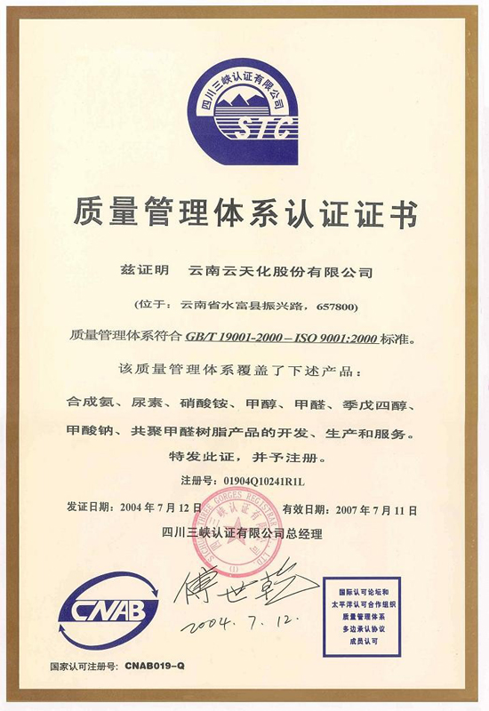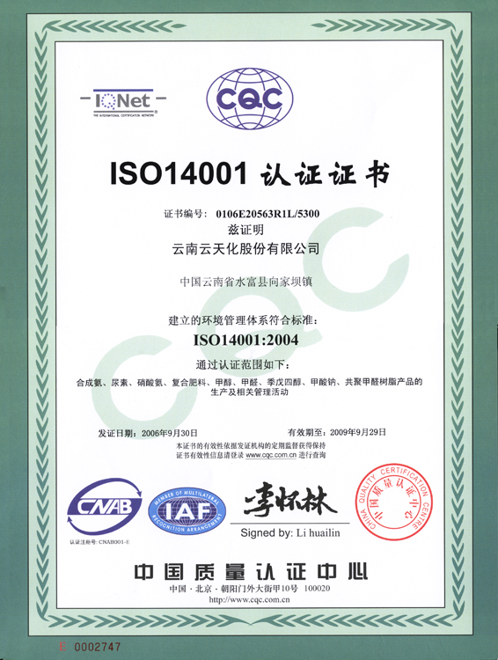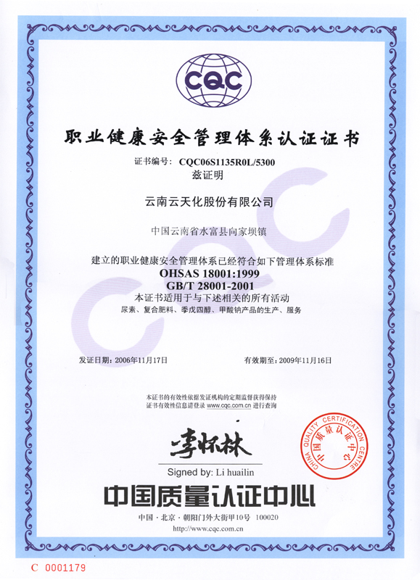

Certification ISO 9000 Certification ISO 14001 Certification ISO 18001
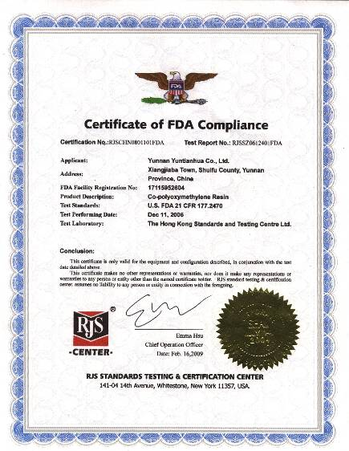
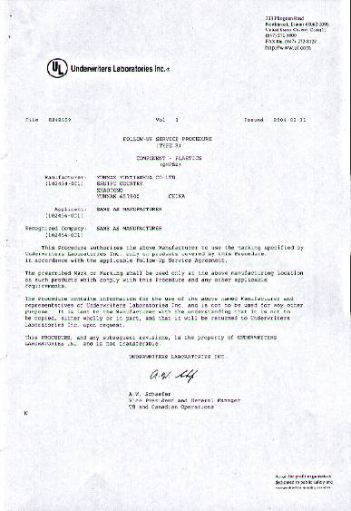
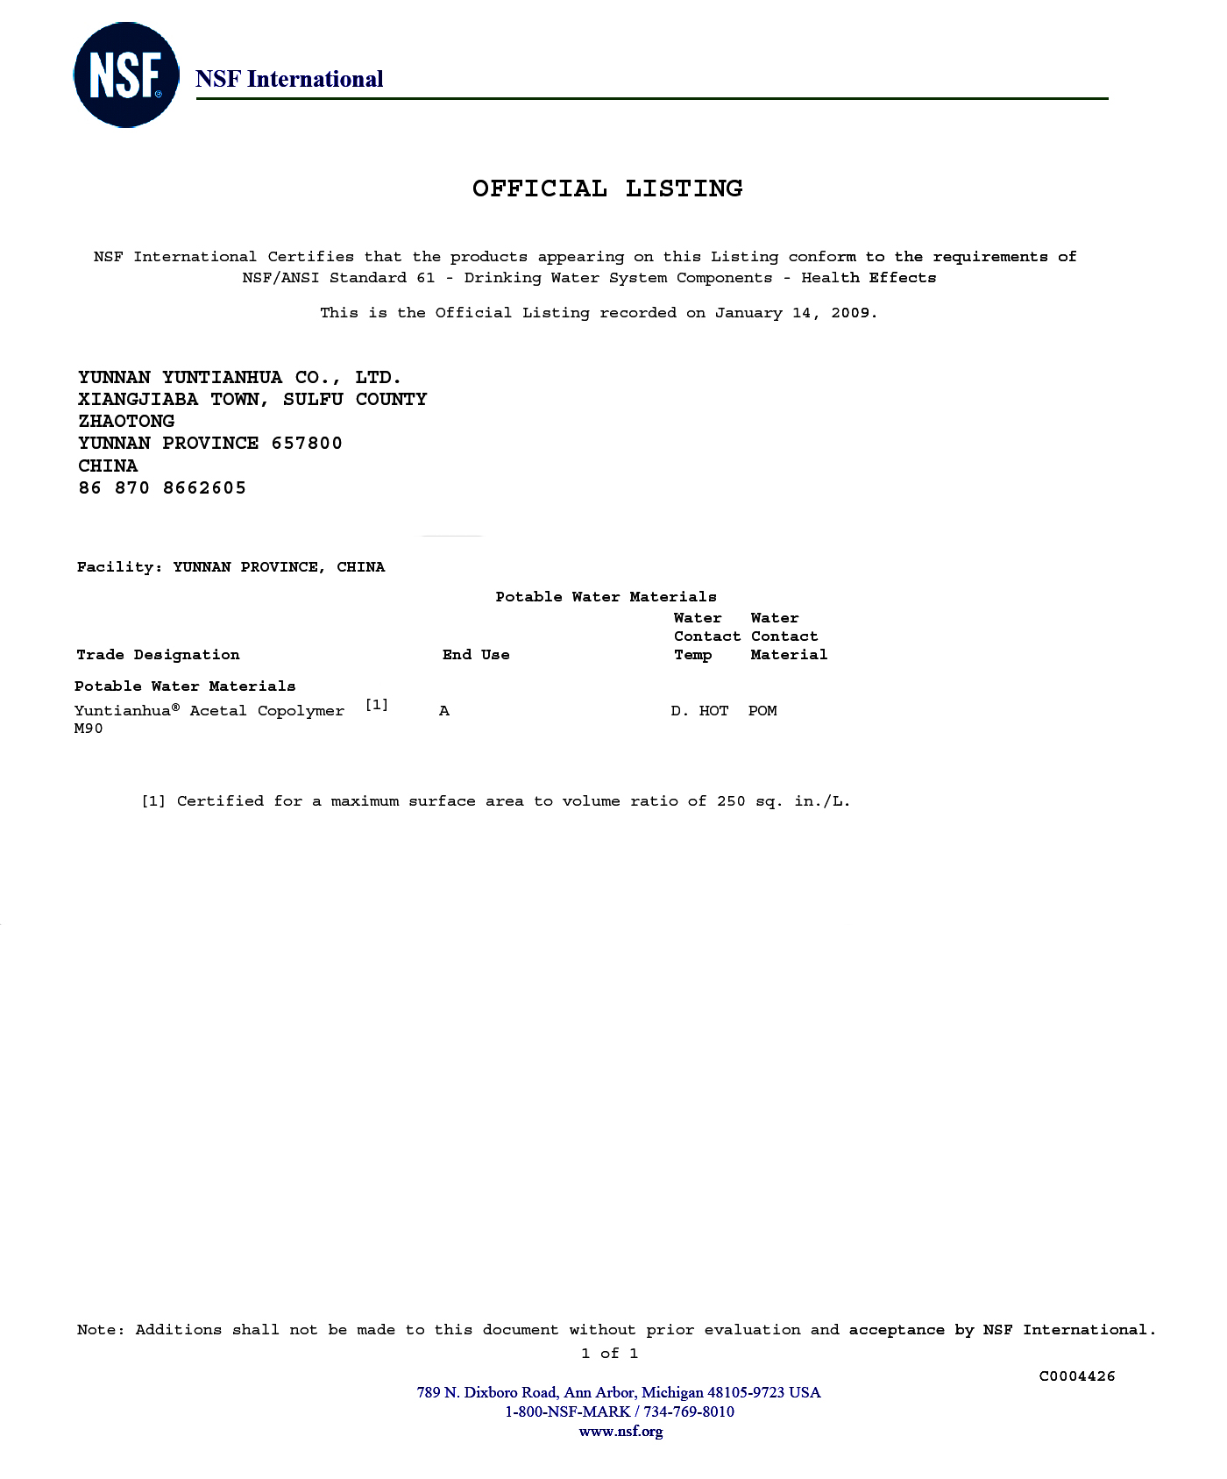

FDA Certification NSF Certification UL Certification
(No.：RJSCHN0612401FDA) （No.：E242659）
In addition, Yuntianhua® POM has also passed the RoHS test, 6P phthalates test, PFOS test, SHVC test, halogen element test, EN71-3 test, DMF test, etc. implemented by SGS-CSTC chemical laboratory (Shanghai) as well as PONY TESTS for Motorola W18, Bisphenol-A(BPA) ,EN1186, DBT&TBT. For details, please contact Yuntianhua technicians.

6 Applications of Yuntianhua® POM

Yuntianhua® POM has excellent comprehensive performance, it is widely applied in many fields, such as automobile industry, mechanical equipments, instrumentations, electronics and appliances, construction materials, agricultural machinery, light industrial, office facilities and chemical equipment components, etc.

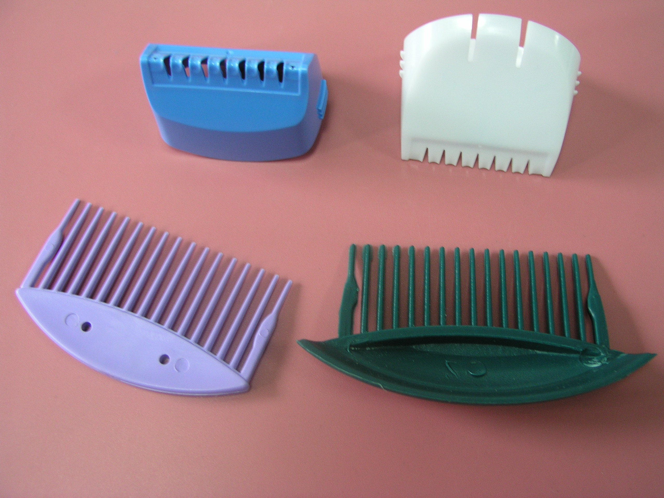
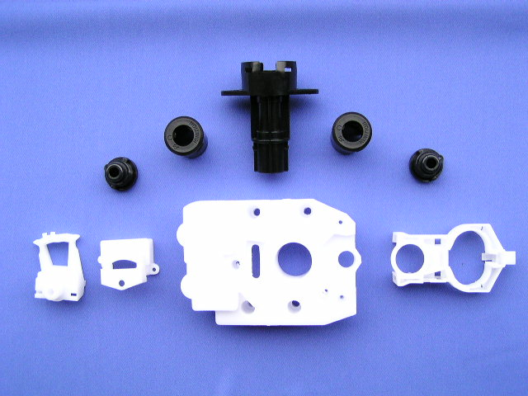
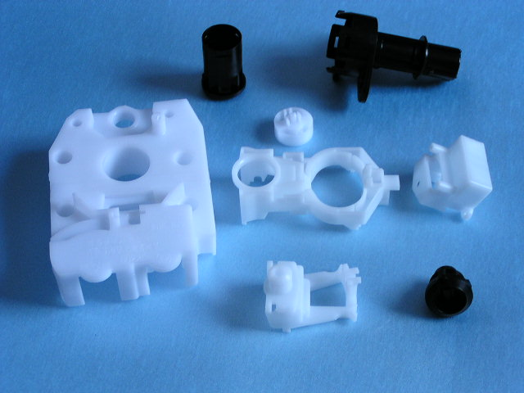
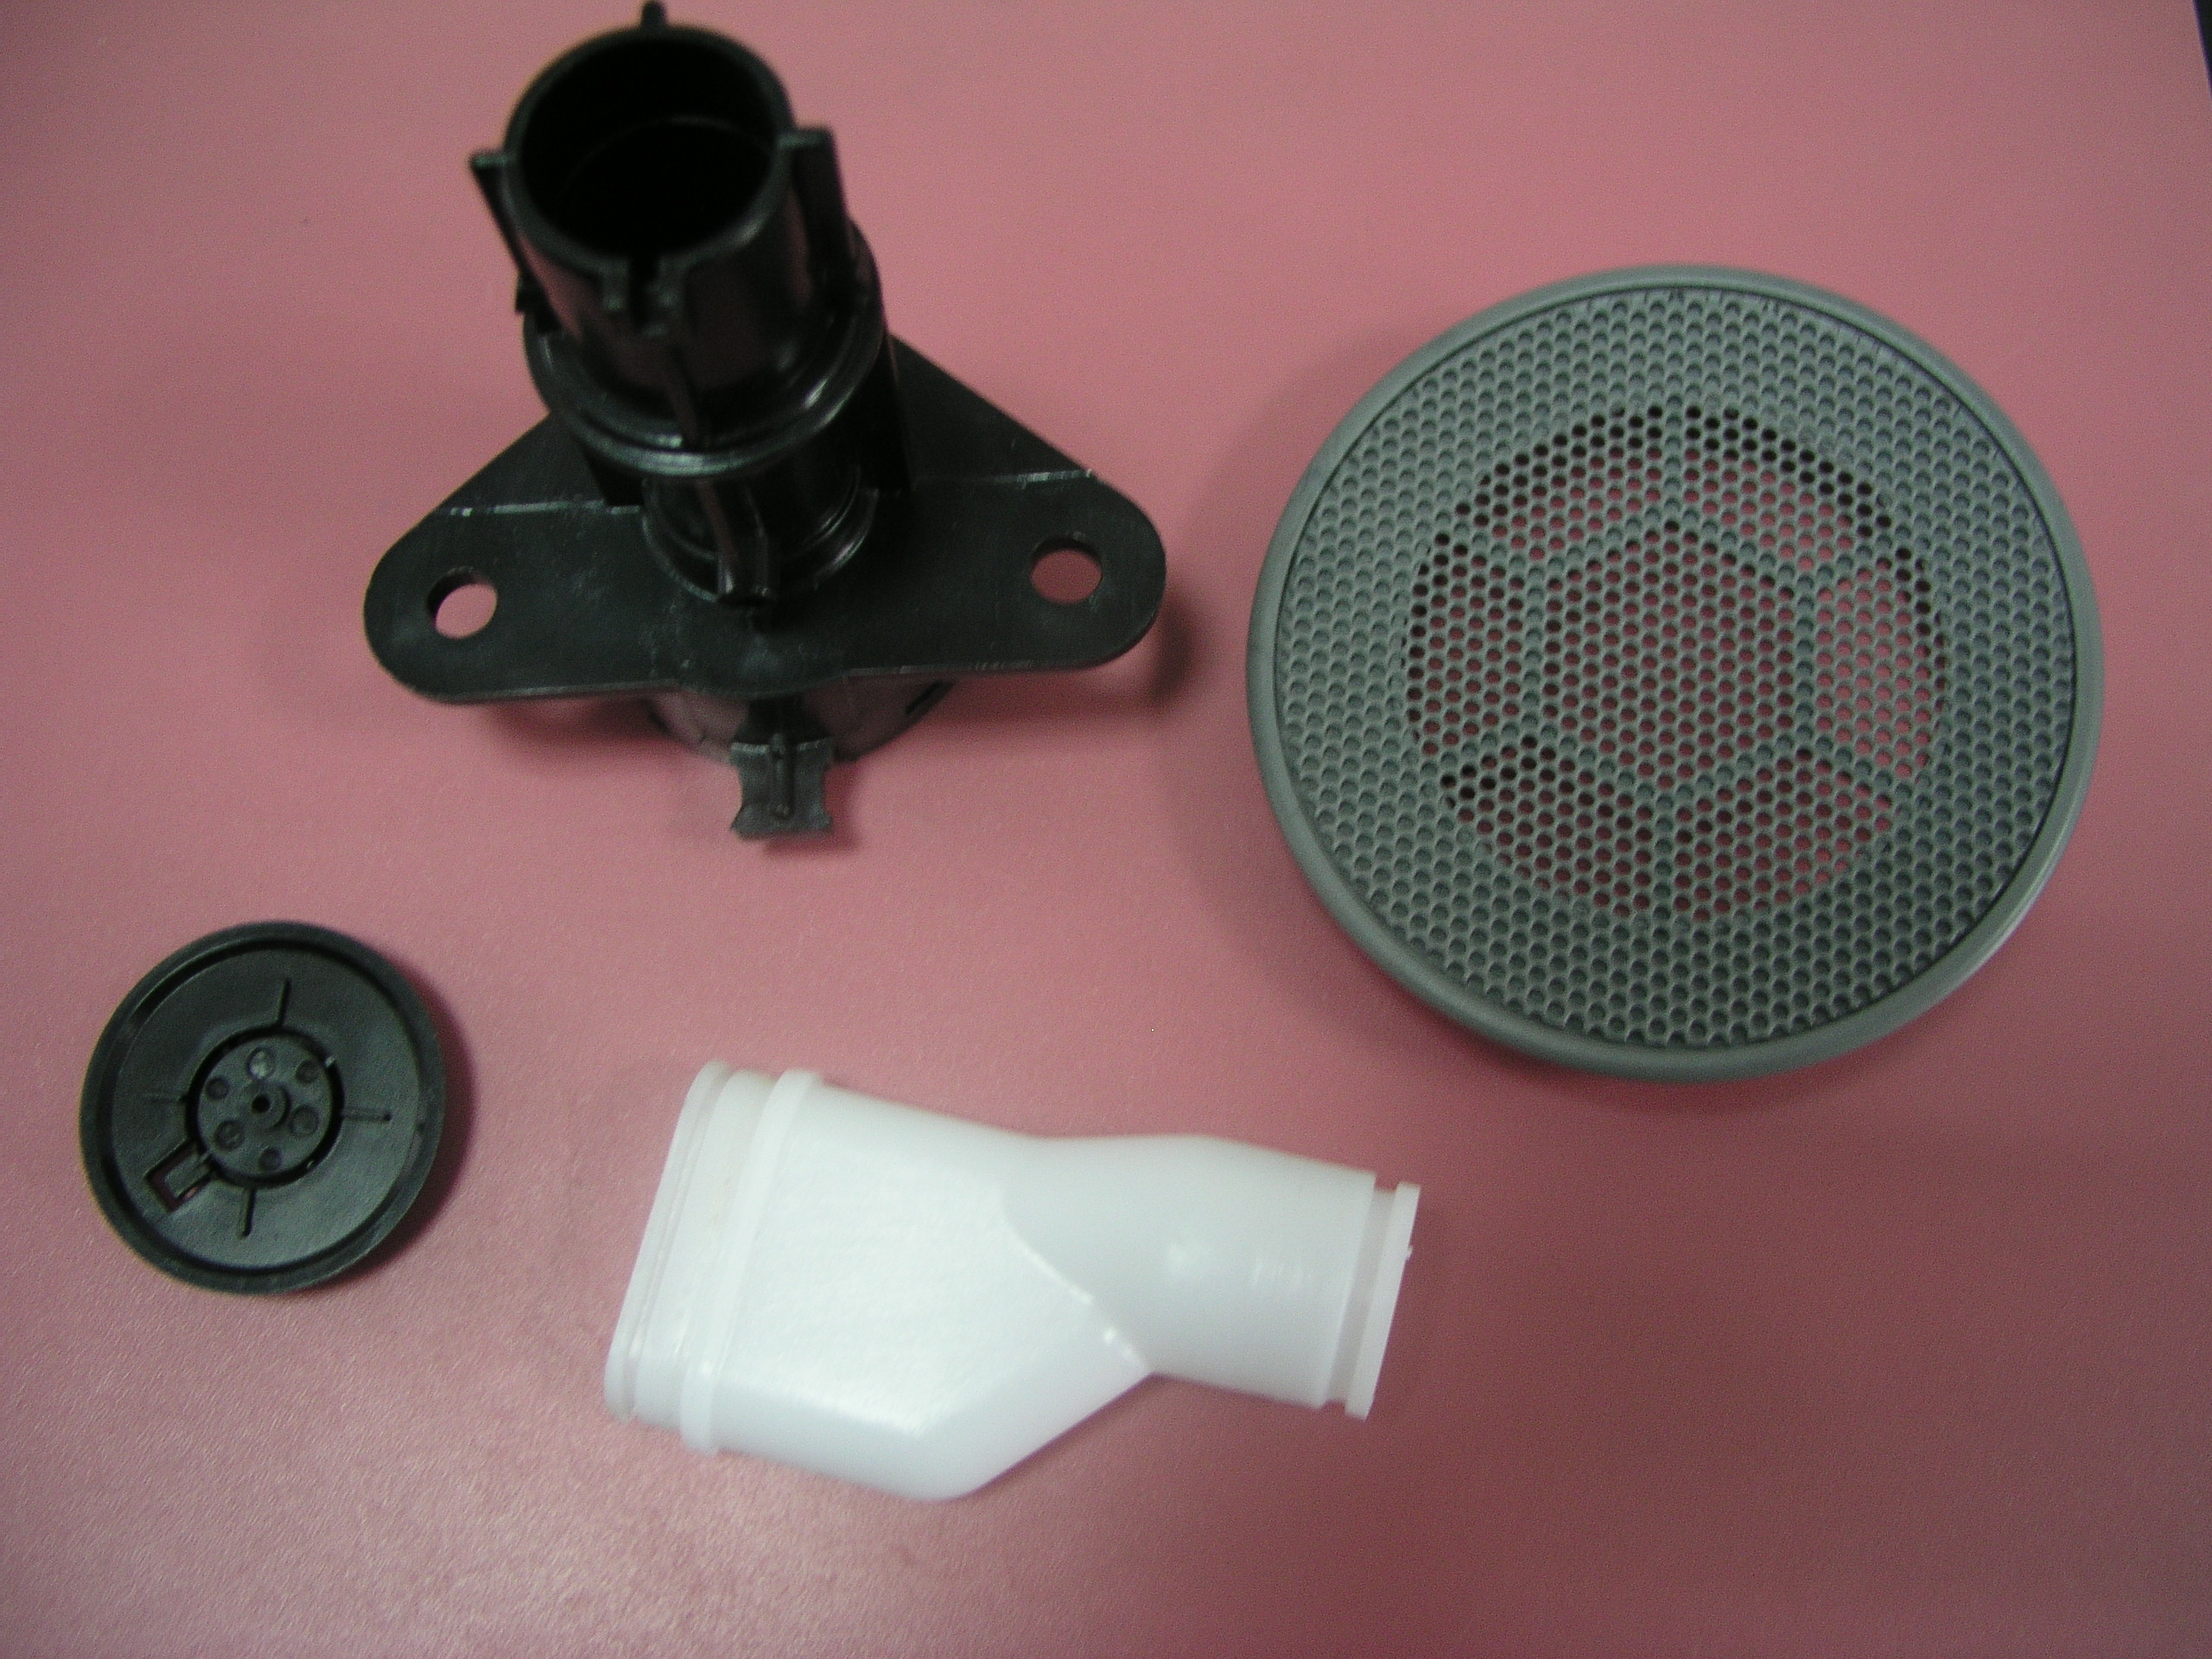
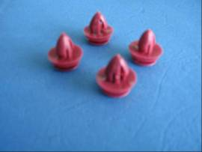
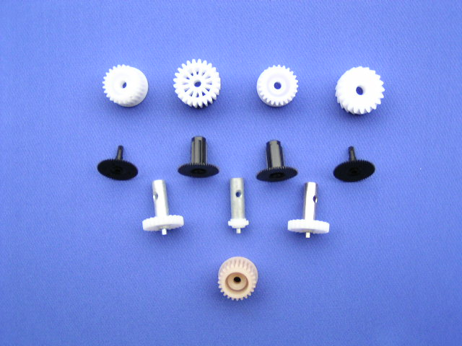
Combs Car Accessories Car Accessories
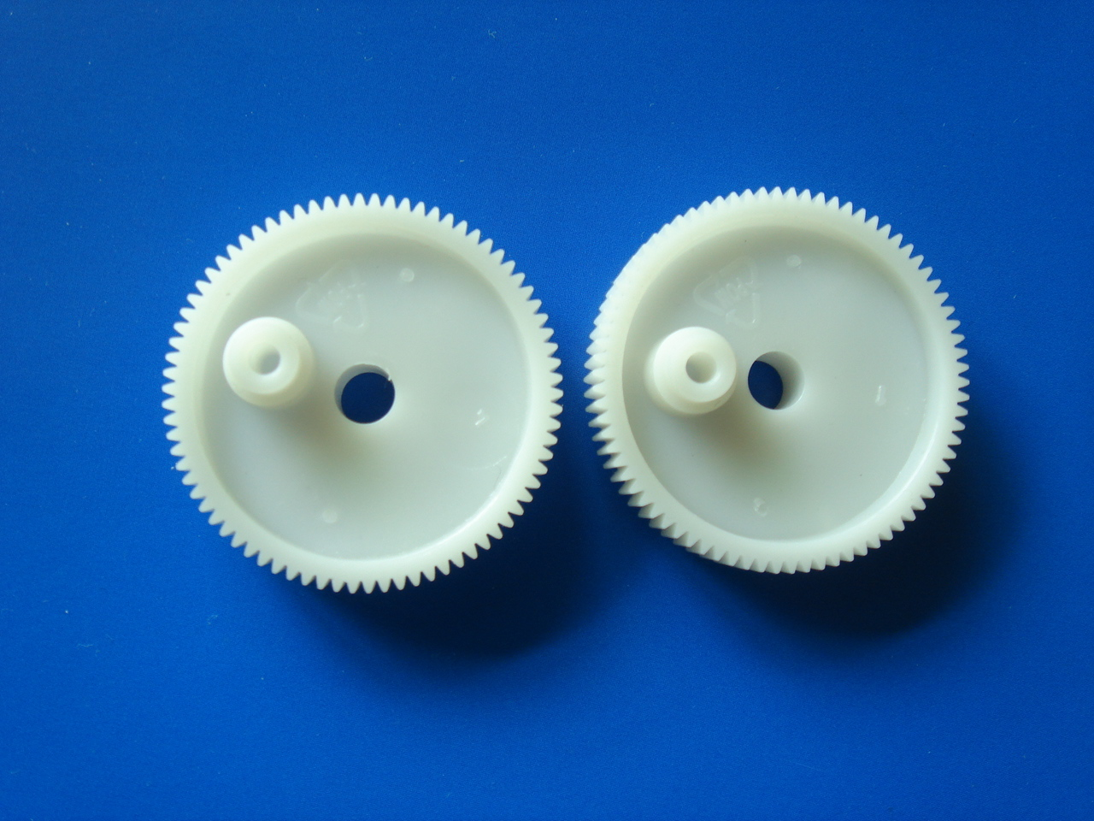
Car Accessories Electronic parts
Electronic gears

